Table A 1: Sampling and Study Design
Table of Study population (4.2)
Stratum (Sub-  Area) of Korail slum | Estimated  Households | Sample Size  (Proportional) | Sampling Technique
Beltola | 2,274 | 40 × (2,274 / 12,703) ≈ 7 | Simple Random  Sampling
Bou Bazar | 5,059 | 40 × (5,059 / 12,703) ≈ 16 | Simple Random  Sampling
Jamai Bazar | 5,370 | 40 × (5,370 / 12,703) ≈ 17 | Simple Random  Sampling
Total | 12,703 | 40

Stratum (Sub-  Area) of Kollyanpur Porah Slum | Estimated  Households | Sample Size  (Proportional) | Sampling Technique
Dakshin Paikpara | 950 | 40 × (950 / 3,700) ≈ 10 | Simple Random  Sampling
Madhya Paikpara | 1,000 | 40 × (1,000 / 3,700) ≈ 11 | Simple Random  Sampling
Uttar Paikpara | 800 | 40 × (800 / 3,700) ≈ 9 | Simple Random  Sampling
Kollyanpur Mahalla | 950 | 40 × (950 / 3,700) ≈ 10 | Simple Random  Sampling
Total | 3,700 | 40

Stratum (Sub-Area) of City ColonySlum | Estimated  Households | Sample Size  (Proportional) | Sampling Technique
Near Buddhijibi  Monument | 600 | 40 × (600 / 1,600) ≈ 15 | Simple Random Sampling
Near Graveyard | 500 | 40 × (500 / 1,600) ≈ 12 | Simple Random Sampling
Inner Alley | 500 | 40 × (500 / 1,600) ≈ 13 | Simple Random Sampling
Total | 1,600 | 40
Source: Author’s sampling design based on household population estimates from field mapping in Korail, Kollyanpur, and City Colony slums (2024)
Table A2: Conceptual Framework of the Study
Component | Elements Included | Description / Link to Theory
Migration Process, Social Safety Nets (SSNPs) & Structural Conditions | - Internal migration from northern Bangladesh to Dhaka slums.  - Health aid, food aid, cash transfers, old age allowance, NGO assistance as Social Safety Net components associated with health outcomes.  - Age group, duration of migration, slum location as moderating factors  - Housing quality, sanitation, water access, overcrowding. | Social Determinants of Health (SDH), Gendered displacement and intersectionality implied.
Economic Security | Employment type, income stability, informal labor | Marxist Feminist perspective
Social Capital | Informal networks, community ties, neighbors, NGO links | Bourdieu’s Social Capital
Source: Author’s conceptual framework drawing on Social Determinants of Health (SDH), Michel Foucault (1977), and Pierre Bourdieu (1986).
Table A3: Health problems Distribution
Health Problems | Frequency | Percentage
Cold, Diarrhea | 5 | 4.2
Cold, Uterus disease | 1 | 0.8
Cold, fever | 1 | 0.8
Diarrhoea, Skin disease | 13 | 10.8
Diarrhoea, Uterus disease | 1 | 0.8
Fever, Cold | 7 | 5.8
Fever, Urinating issues | 1 | 0.8
Jaundice, Fever | 3 | 2.5
Piles, Skin diseases | 8 | 6.7
Pneumonia, Fever | 16 | 13.3
Skin Disease, Diarrhoea | 3 | 2.5
Skin Disease, Fever | 9 | 7.5
Skin Disease, Jaundice | 20 | 16.7
Skin Disease, Uterus disease | 18 | 15
Skin disease, Uterus disease | 3 | 2.5
Urinating issue, Skin diseases | 2 | 1.7
Uterus disease, Fever | 6 | 5
Uterus disease, Cold | 3 | 2.5
Total | 120 | 100
Source: Author’s calculations and visualization based on survey data (N = 120 households); Appendix Table of Diagram 1.
Note: Percentages may not sum to 100 due to rounding
Table A 4: Displacement Drivers
Reason | Frequency | Percentage
Drought | 23 | 18.69918699
Starvation due to natural calamities | 15 | 12.19512195
Lack of work due to climate vulnerability | 14 | 11.38211382
Early marriage due to land loss(climate) | 13 | 10.56910569
Crop Damage | 11 | 8.943089431
River erosion | 10 | 8.130081301
Family member's death due to climate disaster | 10 | 8.130081301
Flooding | 8 | 6.504065041
Climate disaster made bound to alter the profession | 7 | 5.691056911
Village Projection Dam destroyed | 6 | 4.878048781
Parents move due to the potential risk of climate vulnerability | 2 | 1.62601626
Water Dam destroyed | 1 | 0.8130081301
Total | 120 | 100
Source: Author’s calculations and visualization based on survey data (N = 120 households); Appendix Table of Diagram 2.
Note: The figure presents the distribution of major climate-related drivers of displacement across different durations of stay in Dhaka (0–5, 6–10, and 11–20 years). Drought and lack of work due to climate vulnerability emerge as the most prominent drivers, particularly among long-term migrants, while river erosion and disaster-related livelihood disruption remain consistent push factors across all groups.

Appendix B: Descriptive Statistics
Table B1: Occupation Distribution
Occupation | Frequency | Percentage
Garment Worker | 11 | 9.166667
Care giver (day care) | 6 | 5
Househelp worker | 20 | 16.66667
Tailoring | 14 | 11.66667
Housewife | 30 | 25
Bhangari | 6 | 5
Sells Pitha | 3 | 2.5
Private clinic | 1 | 0.833333
Sells betel leaf & cigarette | 3 | 2.5
Community health worker | 5 | 4.166667
Sells puffed rice, snacks | 3 | 2.5
Sells groceries | 3 | 2.5
Driving auto rickshaw | 4 | 3.333333
Laundry | 1 | 0.833333
NGO field staff | 8 | 6.666667
Sells Pitha, puffed rice | 2 | 1.666667
 | 120 | 100
Source: Author’s survey data (N = 120 households)

Table B2: Individual-Level Dataset
Household ID | Homeplace before | Who did you migrate with | Vehicle of Migration | Income Before Migration | Income After Migration | Employment Before Migration (Yes/No) | Employment After Migration (Yes/No)
1 | Rangpur | Parents | Bus | 6,000 | 10000 | Yes | Yes
2 | Gaibandha | Relatives | Bus | 0 | 10000 | No | Yes
3 | Rangpur | Relatives | Bus | 3,000 | 8000 | Yes | Yes
4 | Jamalpur | Relatives | Launch | 2000 | 4000 | Yes | Yes
5 | Sirajganj | Relatives | Launch | 0 | 10000 | No | Yes
6 | Sirajganj | Relatives | Launch | 0 | 12000 | No | Yes
7 | Sirajganj | Relatives | Launch | 0 | 10000 | No | Yes
8 | Sirajganj | Parents | Launch | 0 | 10000 | No | Yes
9 | Sirajganj | Parents | Launch | 0 | 5000 | No | No
10 | Sirajganj | Parents | Launch | 0 | 0 | No | No
11 | Kurigram | Parents | Bus | 3000 | 0 | Yes | Yes
12 | Bogura | Parents | Bus | 0 | 5000 | No | Yes
13 | Bogura | In Laws | Bus | 0 | 10000 | No | Yes
14 | Bogura | In Laws | Bus | 2000 | 12000 | Yes | Yes
15 | Bogura | In Laws | Bus | 0 | 10000 | No | Yes
16 | Bogura | In Laws | Bus | 0 | 0 | No | No
17 | Bogura | In Laws | Bus | 0 | 12000 | No | Yes
18 | Bogura | In Laws | Bus | 0 | 10000 | No | Yes
19 | Bogura | In Laws | Bus | 0 | 0 | No | No
20 | Nilphamari | In Laws | Bus | 0 | 8000 | No | Yes
21 | Nilphamari | In Laws | Bus | 0 | 10000 | No | Yes
22 | Nilphamari | In Laws | Bus | 0 | 0 | No | No
23 | Nilphamari | Parents | Bus | 0 | 2000 | No | Yes
24 | Kurigram | Grandparents | Bus | 0 | 8000 | No | Yes
25 | Nilphamari | Grandparents | Bus | 0 | 8000 | No | Yes
26 | Nilphamari | Grandparents | Bus | 0 | 0 | No | No
27 | Nilphamari | Grandparents | Bus | 0 | 0 | No | No
28 | Nilphamari | Grandparents | Train | 0 | 8000 | No | Yes
29 | Nilphamari | Grandparents | Bus | 3000 | 10000 | Yes | Yes
30 | Nilphamari | Son | Bus | 0 | 5000 | No | Yes
31 | Lalmonirhat | Relatives | Bus | 0 | 10000 | No | Yes
32 | Lalmonirhat | Thyself | Bus | 0 | 5000 | No | Yes
33 | Lalmonirhat | In Laws | Bus | 0 | 5000 | No | Yes
34 | Kurigram | In Laws | Bus | 0 | 10000 | No | Yes
35 | Lalmonirhat | In Laws | Bus | 0 | 5000 | No | Yes
36 | Rangpur | In Laws | Bus | 0 | 10000 | No | Yes
37 | Rangpur | In Laws | Bus | 0 | 8000 | No | Yes
38 | Rangpur | In Laws | Bus | 0 | 0 | No | No
39 | Rangpur | In Laws | Bus | 0 | 6000 | No | Yes
40 | Rangpur | In Laws | Bus | 0 | 0 | No | No
41 | Rangpur | In Laws | Bus | 0 | 10000 | No | Yes
42 | Lalmonirhat | Thyself | Bus | 0 | 10000 | No | Yes
43 | Lalmonirhat | Parents | Bus | 2000 | 10000 | Yes | Yes
44 | Lalmonirhat | Parents | Bus | 0 | 5000 | No | Yes
45 | Kurigram | Parents | Bus | 0 | 10000 | No | Yes
46 | Rangpur | Parents | Bus | 0 | 0 | No | No
47 | Gaibandha | Thyself | Bus | 0 | 0 | No | No
48 | Gaibandha | Thyself | Bus | 0 | 5000 | No | Yes
49 | Gaibandha | Thyself | Bus | 0 | 2000 | No | Yes
50 | Gaibandha | Thyself | Bus | 0 | 0 | No | No
51 | Kurigram | In Laws | Bus | 0 | 15000 | No | Yes
52 | Lalmonirhat | In Laws | Bus | 0 | 5000 | No | Yes
53 | Lalmonirhat | In Laws | Bus | 0 | 10000 | No | Yes
54 | Lalmonirhat | In Laws | Bus | 3000 | 8000 | Yes | Yes
55 | Gaibandha | In Laws | Bus | 0 | 10000 | No | Yes
56 | Gaibandha | In Laws | Bus | 0 | 12000 | No | Yes
57 | Gaibandha | In Laws | Bus | 0 | 12000 | No | Yes
58 | Gaibandha | Son | Bus | 0 | 10000 | No | Yes
59 | Gaibandha | Son | Bus | 0 | 0 | No | No
60 | Kurigram | Parents | Bus | 0 | 5000 | No | Yes
61 | Sherpur | Parents | Bus | 0 | 10000 | No | Yes
62 | Sherpur | Parents | Bus | 0 | 2000 | No | Yes
63 | Sherpur | In Laws | Bus | 0 | 3000 | No | Yes
64 | Sherpur | Parents | Bus | 0 | 10000 | No | Yes
65 | Sherpur | Parents | Bus | 0 | 10000 | No | Yes
66 | Kurigram | Parents | Train | 0 | 0 | No | No
67 | Gaibandha | Relatives | Bus | 0 | 0 | No | No
68 | Gaibandha | Relatives | Bus | 2000 | 10000 | Yes | Yes
69 | Gaibandha | Relatives | Bus | 0 | 5000 | No | Yes
70 | Gaibandha | Relatives | Bus | 0 | 2000 | No | Yes
71 | Gaibandha | In Laws | Bus | 0 | 5000 | No | Yes
72 | Jamalpur | In Laws | Bus | 0 | 5000 | No | Yes
73 | Jamalpur | In Laws | Bus | 0 | 8000 | No | Yes
74 | Jamalpur | In Laws | Bus | 0 | 10000 | No | Yes
75 | Jamalpur | In Laws | Bus | 0 | 8000 | No | Yes
76 | Kurigram | In Laws | Bus | 0 | 10000 | No | Yes
77 | Kurigram | In Laws | Bus | 0 | 10000 | No | Yes
78 | Kurigram | In Laws | Bus | 0 | 0 | No | No
79 | Kurigram | Relatives | Bus | 0 | 5000 | No | Yes
80 | Kurigram | Relatives | Bus | 0 | 0 | No | No
81 | Kurigram | Relatives | Bus | 6000 | 10000 | Yes | Yes
82 | Kurigram | Relatives | Bus | 0 | 10000 | No | Yes
83 | Kurigram | Relatives | Bus | 0 | 10000 | No | Yes
84 | Kurigram | In Laws | Bus | 0 | 2000 | No | Yes
85 | Jamalpur | In Laws | Launch | 0 | 10000 | No | Yes
86 | Jamalpur | In Laws | Launch | 0 | 0 | No | No
87 | Jamalpur | In Laws | Launch | 0 | 0 | No | No
88 | Jamalpur | In Laws | Bus | 0 | 5000 | No | Yes
89 | Sherpur | In Laws | Bus | 0 | 2000 | No | Yes
90 | Sherpur | In Laws | Bus | 0 | 0 | No | No
91 | Sherpur | In Laws | Bus | 0 | 0 | No | No
92 | Sherpur | In Laws | Bus | 0 | 5000 | No | Yes
93 | Sherpur | In Laws | Bus | 0 | 10000 | No | Yes
94 | Sherpur | In Laws | Bus | 3000 | 8000 | Yes | Yes
95 | Sherpur | In Laws | Bus | 0 | 10000 | No | Yes
96 | Sherpur | In Laws | Bus | 0 | 0 | No | No
97 | Jamalpur | In Laws | Launch | 0 | 10000 | No | Yes
98 | Jamalpur | In Laws | Launch | 0 | 10000 | No | Yes
99 | Jamalpur | Son | Launch | 0 | 0 | No | No
100 | Jamalpur | Son | Launch | 0 | 5000 | No | Yes
101 | Gaibandha | In Laws | Bus | 0 | 10000 | No | Yes
102 | Gaibandha | In Laws | Bus | 0 | 2000 | No | Yes
103 | Sherpur | In Laws | Bus | 0 | 6000 | No | Yes
104 | Gaibandha | Parents | Bus | 0 | 8000 | No | Yes
105 | Gaibandha | Parents | Bus | 0 | 10000 | No | Yes
106 | Gaibandha | Parents | Bus | 0 | 0 | No | No
107 | Gaibandha | Parents | Bus | 0 | 0 | No | No
108 | Gaibandha | Parents | Bus | 2000 | 10000 | Yes | Yes
109 | Rangpur | Parents | Bus | 0 | 5000 | No | Yes
110 | Rangpur | Parents | Bus | 0 | 8000 | No | Yes
111 | Rangpur | Parents | Bus | 0 | 10000 | No | Yes
112 | Rangpur | Parents | Train | 0 | 6000 | No | Yes
113 | Sirajganj | Relatives | Launch | 0 | 10000 | No | Yes
114 | Sirajganj | Relatives | Launch | 0 | 10000 | No | Yes
115 | Sirajganj | Relatives | Launch | 0 | 8000 | No | Yes
116 | Sirajganj | Relatives | Launch | 0 | 10000 | No | Yes
117 | Rangpur | Relatives | Train | 0 | 10000 | No | Yes
118 | Rangpur | Thyself | Bus | 0 | 0 | No | No
119 | Rangpur | Thyself | Bus | 0 | 10000 | No | Yes
120 | Rangpur | Thyself | Bus | 0 | 0 | No | No
Source: Author’s collected 120 household survey data that shows the migration scenario

Appendix C: Migration and Income Dataset
Table C1: Age and Income Range Association
Age Range-  Korail | Frequency | Percentage |  | Income  Range | Frequenc  y | Percentage
20–29 | 19 | 47.5 |  | 10–20k | 64 | 52.03252
30–39 | 8 | 20 |  | 20–50k | 43 | 34.95935
50+ | 8 | 20 |  | 5–10k | 12 | 9.756098
40–49 | 5 | 12.5 |  | 0–5k | 1 | 0.813008
Total | 40 | 100 |  | Total | 120 | 100

Income before Migration | Frequency | Percentage
1–5k | 118 | 98.3333333  3
5–10k | 2 | 1.66666666  7

Category-Kollyanpur |  | Frequency | Percentage | Category-City Colony | Frequency | Percentage
20–29 |  | 19 | 46.34146341 | 20–29 | 18 | 45
30–39 |  | 9 | 21.95121951 | 30–39 | 10 | 25
50+ |  | 8 | 19.51219512 | 50+ | 7 | 17.5
40–49 |  | 4 | 9.756097561 | 40–49 | 5 | 12.5
Total |  | 40 | 100 | Total | 40 | 100
 | Age Group | Family Members | Salary (BDT per month) | Region | Household (No. of Representatives)
 | 20-35 years | - | Below 3000 | Karail Slum (Beltola) | 40
 |  | - | Above 3000 | Karail Slum (Beltola) | 15
 |  | - | Unemployed | Karail Slum (Beltola) | 20
 |  | - | Any Allowance from Government | Karail Slum (Beltola) | 25
 |  | - | NGO Assistance | Karail Slum (Beltola) | 35
 |  | - | Community Clinic Accessibility (Alo Clinic) | Karail Slum (Beltola) | 60
 |  | - | Delivery Center Facility Received | Karail Slum (Beltola) | 30
 |  | - | Health Service Adviser Visit (Contraception, Menstrual Hygiene Awareness) | Karail Slum (Beltola) | 10
 |  | - | Health Disease Support (Waterborne diseases, Diarrhea, Cholera, etc.) | Karail Slum (Beltola) | 10
 |  | - | DSK (Dhaka Slum Karail) Project Association | Karail Slum (Beltola) | 35
 |  | - | Suniti Prakalpa for Slum Women Association | Karail Slum (Beltola) | 15
 |  | - | GBV Protection Awareness (Calling 109, 911, Filing a Case to PCSW Cyber Cell) | Karail Slum (Beltola) | 10
 |  | - | Free Treatment Availability | Karail Slum (Beltola) | 25
 |  | - | Out of Community Health Service Access | Karail Slum (Beltola) | 6
 | 36-55 Years | - | BRAC’s Safety Net Seminar Attendees (Knowledge on Safety Net) | Karail Slum (Beltola) | 2
 |  | - | NID Card Holders | Karail Slum (Beltola) | 4
 |  | - | Bank Account Holders | Karail Slum (Beltola) | 0
 |  | - | Blood Group Tested | Karail Slum (Beltola) | 2
 |  | - | Employed Husband | Karail Slum (Beltola) | 12
 |  | - | Ration Card Holders | Karail Slum (Beltola) | 7
 |  | - | Below 3000 | Karail Slum (Beltola) | -
 |  | - | Above 3000 | Karail Slum (Beltola) | -
 | 56-70 years | - | Below 3000 | Karail Slum (Beltola) | 40
 |  | - | Above 3000 | Karail Slum (Beltola) | 15
Source: Author’s calculations based on survey data (N = 120 households) to present the age and income frequency
Appendix D: Education and health hygiene, Migration’s duration and Health Hazard,
Table D1: Health and Aid Variables, Employability/ Income and Healthcare
Aid Received on Health | Aid Received (Yes/No) | Type of Aid Received | Aid From (Govt/NGO/UN agency/  all) | Education Level | House payment | Religion | Wash hand after toilet | Wash hand before eating | Kitchen cleanliness
Free medicines (campaign),free vaccination | Yes | Loan, business aid | NGO | Class 4 | Owner | Muslim | Yes | No | No
Government treatment with small amount | Yes | Loan, skill training | NGO, UN Agency | Class 2 | Owner | Muslim | Yes | No | No
Government treatment with small amount,free vaccination | Yes | Loan, allowance | Government, NGO | Class 1 | Owner | Muslim | Yes | No | No
Government treatment with small amount,free vaccination | Yes | Loan | NGO | Class 5 | Owner | Muslim | Yes | No | No
Government treatment with small amount,free vaccination | Yes | Loan | NGO | Class 5 | Owner | Muslim | Yes | No | No
Government treatment with small amount | Yes | Loan, business aid | NGO | SSC | Owner | Muslim | Yes | No | No
Free medicines (campaign) | Yes | Loan | NGO | Class 8 | Owner | Muslim | Yes | No | No
Free medicines (campaign) | Yes | Loan | NGO | Class 5 | Owner | Muslim | Yes | No | No
Free medicines (campaign),free vaccination | Yes | Loan | NGO | Class 5 | Owner | Muslim | Yes | No | No
Free medicines (campaign) | Yes | Loan, skill training | NGO, UN Agency | Class 5 | Owner | Muslim | Yes | No | No
Never received | Yes | Loan, allowance | Government, NGO | Class 5 | Owner | Muslim | Yes | No | No
Free medicines (campaign) | Yes | Loan, skill training | NGO, UN Agency | Class 5 | Owner | Muslim | Yes | No | No
Government treatment with small amount | Yes | Loan, allowance | Government, NGO | HSC | Owner | Muslim | Yes | Yes | Yes
Government treatment with small amount | Yes | Loan, skill training | NGO, UN Agency | SSC | Owner | Muslim | Yes | Yes | Yes
Government treatment with small amount | Yes | Loan, food support | Government, NGO | Class 8 | Owner | Muslim | Yes | Yes | Yes
Government treatment with small amount | Yes | Loan, business aid | NGO | Class 8 | Owner | Muslim | Yes | No | No
Government treatment with small amount | Yes | Loan, food support | Government, NGO | Read Arabic | Owner | Muslim | Yes | No | No
Free medicines (campaign) | Yes | Loan, allowance | Government, NGO | HSC | Owner | Muslim | Yes | No | No
Free medicines (campaign) | Yes | Loan, skill training | NGO, UN Agency | HSC | Owner | Muslim | Yes | No | No
Government treatment with small amount | Yes | Loan | NGO | SSC | Owner | Muslim | Yes | Yes | Yes
Government treatment with small amount,free vaccination | Yes | Loan, skill training | NGO, UN Agency | Honour's 2nd year | Owner | Muslim | Yes | No | No
Government treatment with small amount | Yes | Loan, skill training | NGO, UN Agency | Class 4 | Owner | Muslim | Yes | No | No
Government treatment with small amount | Yes | Loan | NGO | Class 2 | Owner | Muslim | Yes | No | No
Government treatment with small amount,free vaccination | Yes | Loan, skill training | NGO, UN Agency | HSC | Owner | Hindu | Yes | Yes | Yes
Never received | Yes | Loan, business aid | NGO | HSC | Owner | Muslim | Yes | Yes | Yes
Never received | Yes | Loan | NGO | Class 2 | Owner | Muslim | Yes | No | No
Never received | Yes | Loan | NGO | Read Arabic | Owner | Muslim | Yes | No | No
Never received | Yes | Skill training | UN Agency | Class 3 | Owner | Hindu | Yes | No | No
Never received | Yes | Loan | NGO | Class 5 | Owner | Muslim | Yes | No | No
Government treatment with small amount | Yes | Loan | NGO | Class 2 | Owner | Muslim | Yes | No | No
Government treatment with small amount | Yes | Loan, skill training | NGO, UN Agency | SSC | Owner | Muslim | Yes | Yes | Yes
Government treatment with small amount,free vaccination | Yes | Loan, food support | Government, NGO | Class 5 | Owner | Muslim | Yes | No | No
Never received | Yes | Loan, skill training | NGO, UN Agency | Diploma Nursing | Owner | Hindu | Yes | No | No
Never received | Yes | Loan, skill training | NGO, UN Agency | Class 9 | Owner | Muslim | Yes | No | No
Never received | Yes | Loan, skill training | NGO, UN Agency | Class 3 | Owner | Muslim | Yes | No | No
Never received | Yes | Loan | NGO | Class 4 | Owner | Muslim | Yes | No | No
Never received | Yes | Loan, stipend for child | Government, NGO | HSC | Owner | Muslim | Yes | No | Yes
Never received | Yes | Loan | NGO | SSC | Owner | Muslim | Yes | Yes | Yes
Free medicines (campaign) | Yes | business aid | NGO | Class 5 | Owner | Muslim | Yes | No | No
Free medicines (campaign),free vaccination | Yes | Loan | NGO | Class 5 | Owner | Muslim | Yes | No | No
Government treatment with small amount | Yes | Loan | NGO | Class 5 | Owner | Hindu | Yes | No | No
Government treatment with small amount | Yes | Loan, business aid | NGO | Class 5 | Owner | Muslim | Yes | No | No
Government treatment with small amount | Yes | Loan, food support | Government, NGO | Class 5 | Owner | Muslim | Yes | No | No
Government treatment with small amount | Yes | Loan | NGO | Read Arabic | Owner | Muslim | Yes | No | No
Government treatment with small amount | Yes | Loan | NGO | Read Arabic | Owner | Muslim | Yes | No | No
Free medicines (campaign) | Yes | Loan | NGO | Can't Read | Owner | Muslim | Yes | No | Yes
Free medicines (campaign) | Yes | Loan | NGO | Read Arabic | Owner | Muslim | Yes | No | Yes
Government treatment with small amount | Yes | Loan | NGO | Class 3 | Owner | Muslim | Yes | No | Yes
Government treatment with small amount,free vaccination | Yes | Loan | NGO | Diploma Nursing | Owner | Muslim | Yes | Yes | Yes
Government treatment with small amount | Yes | Loan, skill training | NGO, UN Agency | HSC | Owner | Muslim | Yes | Yes | Yes
Never received | Yes | Loan | NGO | Class 4 | Owner | Muslim | Yes | No | No
Free vaccination | Yes | Loan | NGO | Class 4 | Owner | Muslim | Yes | No | No
Never received | Yes | Loan | NGO | Class 4 | Owner | Muslim | Yes | No | No
Never received | Yes | Loan | NGO | Class 4 | Owner | Muslim | Yes | No | No
Never received | Yes | Loan | NGO | Read Arabic | Owner | Muslim | Yes | No | No
Never received | Yes | Loan, skill training | NGO, UN Agency | Class 2 | Owner | Muslim | Yes | No | No
Never received | Yes | Loan | NGO | Class 4 | Owner | Muslim | Yes | No | No
Free vaccination | Yes | Loan | NGO | Class 2 | Owner | Muslim | Yes | No | No
Free vaccination | Yes | Loan | NGO | Class 1 | Owner | Muslim | Yes | No | No
Free vaccination | Yes | Loan | NGO | Read Arabic | Owner | Muslim | Yes | No | No
Free vaccination | Yes | Loan, business aid | NGO | Class 5 | Owner | Muslim | Yes | No | No
Never received | Yes | Loan,stipend for child | Government, NGO | Class 5 | Owner | Muslim | Yes | No | No
Never received | Yes | Loan, food support | Government, NGO | Class 5 | Owner | Muslim | Yes | No | No
Never received | Yes | Loan, allowance | Government, NGO | Class 5 | Owner | Muslim | Yes | No | No
Never received | Yes | Loan, food support | Government, NGO | Class 5 | Owner | Muslim | Yes | No | No
Never received | Yes | Loan | NGO | Class 5 | Owner | Muslim | Yes | No | No
Never received | Yes | Loan | NGO | Class 5 | Owner | Muslim | Yes | No | No
Never received | Yes | Loan | NGO | SSC | Owner | Muslim | Yes | Yes | Yes
Never received | Yes | Loan, food support | Government, NGO | HSC | Owner | Muslim | Yes | Yes | Yes
Government treatment with small amount | Yes | Loan, business aid | NGO | Class 7 | Owner | Muslim | Yes | No | No
Government treatment with small amount | Yes | Loan, skill training | NGO, UN Agency | Honour's 2nd year | Owner | Hindu | Yes | Yes | Yes
Government treatment with small amount | Yes | Loan, skill training | NGO, UN Agency | HSC | Owner | Muslim | Yes | No | No
Government treatment with small amount | Yes | Loan | NGO | Class 3 | Owner | Muslim | Yes | No | No
Government treatment with small amount,free vaccination | Yes | Loan | NGO | Class 4 | Owner | Hindu | Yes | No | No
Government treatment with small amount | Yes | Skill training | UN Agency | Class 2 | Owner | Hindu | Yes | No | No
Free vaccination | Yes | Loan | NGO | Class 5 | Owner | Hindu | Yes | No | No
Free vaccination | Yes | Loan, business aid | NGO | HSC | Owner | Muslim | Yes | Yes | Yes
Free medicines (campaign) | Yes | Loan, business aid | NGO | SSC | Owner | Muslim | Yes | Yes | Yes
Free medicines (campaign) | Yes | Loan, food support | Government, NGO | Class 8 | Owner | Muslim | Yes | No | No
Free medicines (campaign),free vaccination | Yes | Loan, business aid | NGO | Class 8 | Owner | Hindu | Yes | No | No
Free medicines (campaign),free vaccination | Yes | Loan | NGO | Diploma Nursing | Owner | Muslim | Yes | Yes | Yes
Free medicines (campaign) | Yes | Loan | NGO | HSC | Owner | Muslim | Yes | Yes | Yes
Free medicines (campaign),free vaccination | Yes | Loan | NGO | SSC | Owner | Muslim | Yes | Yes | Yes
Never received | Yes | Loan | NGO | Class 7 | Owner | Muslim | Yes | No | No
Never received | Yes | Loan | NGO | Class 8 | Owner | Muslim | Yes | No | No
Government treatment with small amount,free vaccination | Yes | Loan | NGO | Class 4 | Owner | Muslim | Yes | No | No
Never received | Yes | Loan | NGO | Class 8 | Owner | Muslim | Yes | No | No
Never received | Yes | Loan | NGO | Class 8 | Owner | Muslim | Yes | No | Yes
Never received | Yes | Loan | NGO | Honour's 2nd year | Owner | Muslim | Yes | Yes | Yes
Government treatment with small amount,free vaccination | Yes | Loan, food support | Government, NGO | SSC | Owner | Muslim | Yes | Yes | Yes
Government treatment with small amount,free vaccination | Yes | Loan | NGO | Class 4 | Owner | Muslim | Yes | No | No
Government treatment with small amount,free vaccination | Yes | Loan | NGO | Class 4 | Owner | Muslim | Yes | No | No
Government treatment with small amount,free vaccination | Yes | Loan | NGO | Class 4 | Owner | Muslim | Yes | No | No
Never received | Yes | Loan | NGO | Class 4 | Owner | Muslim | Yes | No | No
Never received | Yes | Loan, stipend for child | Government, NGO | Class 4 | Owner | Muslim | Yes | No | No
Never received | Yes | Loan | NGO | Class 4 | Owner | Muslim | Yes | No | No
Government treatment with small amount,free vaccination | Yes | Loan, food support | Government, NGO | SSC | Owner | Muslim | Yes | Yes | Yes
Free vaccination | Yes | Loan | NGO | Class 5 | Owner | Muslim | Yes | No | Yes
Never received | Yes | Loan | NGO | Class 2 | Owner | Muslim | Yes | No | Yes
Never received | Yes | Skill Training | UN Agency | Class 5 | Owner | Muslim | Yes | No | Yes
Never received | Yes | Loan, stipend for child | Government, NGO | Illiterate | Owner | Muslim | Yes | No | No
Never received | Yes | Loan | NGO | Class 1 | Owner | Muslim | Yes | No | No
Never received | Yes | Loan | NGO | Class 3 | Owner | Muslim | Yes | No | No
Source: Education and health hygiene and those association with aid

Table D2 : Migration’s duration and Health Hazard
Major Reason of Displacement | Years Staying in Dhaka(0-5) | Years Staying in Dhaka(6-10) | Years Staying in Dhaka(11-20)
Climate disaster-bound to alter the profession | 0 | 0 | 4
Crop Damage | 0 | 3 | 8
Drought | 0 | 1 | 18
Early marriage due to land loss(climate) | 0 | 0 | 10
Family member's death due to climate disaster | 0 | 2 | 7
Flooding | 0 | 1 | 6
Lack of work due to climate vulnerability | 0 | 1 | 12
Parents move- potential risk of climate | 0 | 0 | 2
River erosion | 0 | 2 | 8
Starvation due to natural calamities | 0 | 1 | 8
Village Projection Dam destroyed | 0 | 0 | 5
Water Dam destroyed | 0 | 0 | 1

Types of Health Problems | Affected People
Cold, Diarrhea | 5
Cold, Uterus disease | 1
Cold, fever | 1
Diarrhea, Skin disease | 13
Diarrhea, Uterus disease | 1
Fever, Cold | 7
Fever, Urinating issues | 1
Jaundice, Fever | 3
Piles, Skin diseases | 8
Pneumonia, Fever | 16
Skin Disease, Diarrhea | 3
Skin Disease, Fever | 9
Skin Disease, Jaundice | 20
Skin Disease, Uterus disease | 18
Skin disease, Uterus disease | 3
Urinating issue, Skin diseases | 2
Uterus disease, Fever | 6
Uterus disease,Cold | 3
Source: Calculation of Migration’s duration and the major reasons association with health hazard

Table D3: Employability/ Income and Healthcare
Access to Toilet based on income | Yes | Percentage1 | No | Percentage2
<10k | 12 | 13.95348837 | 5 | 14.70588235
10k-20k | 68 | 79.06976744 | 26 | 76.47058824
>20k | 6 | 6.976744186 | 3 | 8.823529412
Total | 86 | 100 | 34 | 100
Category | Frequency | Percentage
Employability | 64 | 53.33
Free Housing | 4 | 3.33
Healthcare Access | 37 | 30.83
Transportation Facility | 3 | 2.5
Women Empowerment | 12 | 10
Total | 120 | 100
Source: Author’s Calculation between employability/ income and healthcare association
Table D4: Health conditions and Aid receipt
Household ID | Types of Health Problems | Aid Received on Health
1 | Jaundice, Fever | Free medicines (campaign),free vaccination
2 | Diarrhea, Skin disease | Government treatment with small amount
3 | Uterus disease,Cold | Government treatment with small amount,free vaccination
5 | Uterus disease, Fever | Government treatment with small amount,free vaccination
6 | Skin Disease, Jaundice | Government treatment with small amount,free vaccination
7 | Piles, Skin diseases | Government treatment with small amount
8 | Cold, Diarrhea | Free medicines (campaign)
9 | Skin disease, Uterus disease | Free medicines (campaign)
10 | Diarrhea, Skin disease | Free medicines (campaign),free vaccination
11 | Skin Disease, Diarrhea | Free medicines (campaign)
12 | Skin Disease, Jaundice | Never received
13 | Skin Disease, Jaundice | Free medicines (campaign)
15 | Skin Disease, Jaundice | Government treatment with small amount
16 | Skin Disease, Jaundice | Government treatment with small amount
17 | Skin Disease, Uterus disease | Government treatment with small amount
18 | Skin Disease, Jaundice | Government treatment with small amount
19 | Skin Disease, Jaundice | Government treatment with small amount
20 | Skin Disease, Jaundice | Free medicines (campaign)
21 | Urinating issue, Skin diseases | Free medicines (campaign)
22 | Fever, Cold | Government treatment with small amount
23 | Piles, Skin diseases | Government treatment with small amount,free vaccination
24 | Uterus disease, Fever | Government treatment with small amount
25 | Diarrhea, Skin disease | Government treatment with small amount
27 | Piles, Skin diseases | Government treatment with small amount,free vaccination
28 | Fever, Cold | Never received
29 | Diarrhea, Skin disease | Never received
30 | Pneumonia, Fever | Never received
31 | Skin Disease, Fever | Never received
32 | Skin Disease, Jaundice | Never received
34 | Skin Disease, Uterus disease | Government treatment with small amount
35 | Skin Disease, Jaundice | Government treatment with small amount
36 | Fever, Cold | Government treatment with small amount,free vaccination
37 | Piles, Skin diseases | Never received
38 | Uterus disease, Fever | Never received
39 | Diarrhea, Skin disease | Never received
40 | Cold, Diarrhea | Never received
41 | Piles, Skin diseases | Never received
42 | Skin Disease, Uterus disease | Never received
44 | Skin Disease, Fever | Free medicines (campaign)
45 | Skin Disease, Jaundice | Free medicines (campaign),free vaccination
46 | Skin Disease, Fever | Government treatment with small amount
47 | Skin Disease, Jaundice | Government treatment with small amount
48 | Skin Disease, Fever | Government treatment with small amount
49 | Skin Disease, Uterus disease | Government treatment with small amount
50 | Skin Disease, Uterus disease | Government treatment with small amount
51 | Skin Disease, Uterus disease | Free medicines (campaign)
52 | Skin Disease, Uterus disease | Free medicines (campaign)
53 | Skin Disease, Uterus disease | Government treatment with small amount
54 | Uterus disease, Fever | Government treatment with small amount,free vaccination
55 | Cold, Uterus disease | Government treatment with small amount
56 | Urinating issue, Skin diseases | Never received
57 | Diarrhea, Uterus disease | Free vaccination
58 | Skin Disease, Uterus disease | Never received
59 | Skin Disease, Uterus disease | Never received
60 | Skin Disease, Uterus disease | Never received
61 | Skin Disease, Uterus disease | Never received
65 | Fever, Cold | Never received
66 | Fever, Cold | Free vaccination
67 | Fever, Cold | Free vaccination
68 | Fever, Cold | Free vaccination
69 | Skin Disease, Uterus disease | Free vaccination
71 | Skin Disease, Uterus disease | Never received
72 | Pneumonia, Fever | Never received
73 | Skin Disease, Fever | Never received
74 | Skin Disease, Jaundice | Never received
75 | Skin Disease, Fever | Never received
76 | Jaundice, Fever | Never received
77 | Diarrhea, Skin disease | Never received
78 | Uterus disease,Cold | Never received
80 | Uterus disease, Fever | Government treatment with small amount
81 | Skin Disease, Jaundice | Government treatment with small amount
82 | Piles, Skin diseases | Government treatment with small amount
83 | Cold, Diarrhea | Government treatment with small amount
84 | Skin disease, Uterus disease | Government treatment with small amount,free vaccination
85 | Diarrhea, Skin disease | Government treatment with small amount
86 | Skin Disease, Diarrhea | Free vaccination
89 | Skin Disease, Fever | Free vaccination
90 | Jaundice, Fever | Free medicines (campaign)
91 | Diarrhea, Skin disease | Free medicines (campaign)
92 | Uterus disease,Cold | Free medicines (campaign),free vaccination
94 | Uterus disease, Fever | Free medicines (campaign),free vaccination
95 | Skin Disease, Jaundice | Free medicines (campaign)
96 | Pneumonia, Fever | Free medicines (campaign),free vaccination
97 | Cold, Diarrhea | Never received
98 | Skin disease, Uterus disease | Never received
99 | Diarrhea, Skin disease | Government treatment with small amount,free vaccination
100 | Skin Disease, Diarrhea | Never received
101 | Skin Disease, Jaundice | Never received
102 | Pneumonia, Fever | Never received
103 | Skin Disease, Fever | Government treatment with small amount,free vaccination
104 | Cold, fever | Government treatment with small amount,free vaccination
105 | Pneumonia, Fever | Government treatment with small amount,free vaccination
106 | Piles, Skin diseases | Government treatment with small amount,free vaccination
107 | Piles, Skin diseases | Never received
108 | Diarrhea, Skin disease | Never received
109 | Pneumonia, Fever | Never received
110 | Pneumonia, Fever | Government treatment with small amount,free vaccination
114 | Pneumonia, Fever | Free vaccination
116 | Pneumonia, Fever | Never received
117 | Pneumonia, Fever | Never received
118 | Pneumonia, Fever | Never received
119 | Pneumonia, Fever | Never received
120 | Fever, Urinating issues | Never received
Source: Author’s survey data on health conditions and aid receipt (N = 120 households) that shows the health disease and aid received data
Appendix E: Education, Regression table and the summarized Hypothesis result as an extension
Table E1: Education and Literacy Profile of respondents or their family members
Education Level | Frequency |  |  | Percentages
Class 1 |  |  | 5 | 4.166666667
Class 2 |  |  | 8 | 6.666666667
Class 3 |  |  | 5 | 4.166666667
Class 4 |  |  | 17 | 14.16666667
Class 5 |  |  | 24 | 20
Class 7 |  |  | 2 | 1.666666667
Class 8 |  |  | 8 | 6.666666667
Class 9 |  |  | 1 | 0.833333333
SSC |  |  | 11 | 9.166666667
Table Continued
Education Level | Frequency |  |  | Percentages
Diploma Nursing |  | 3 |  |  | 2.5
HSC |  | 11 |  |  | 9.166666667
Honour's 2nd year |  | 3 |  |  | 2.5
Read Arabic |  | 10 |  |  | 8.333333333
Can Read Basic Letters |  | 1 |  |  | 0.833333333
Can't Read Properly |  | 3 |  |  | 2.5
Illiterate |  | 8 |  |  | 6.666666667
Total |  | 120
Source: Author’s survey data (N = 120 households) to show the education scenario among three slums’ women (Korail, Kallyanpur, City Colony)

Table E2: Logistic Regression Results for Good Self-Reported Health
Variable | Odds Ratio (OR) | 95% CI | p-value
Safety net (Yes vs No) | 0.73 | 0.27 – 1.89 | 0.522
Clinic access (Yes vs No) | 3.34 | 1.30 – 8.88 | 0.013*
Income after migration (per BDT) | 1.0001 | 0.99 – 1.0002 | 0.086
Flood/Erosion (vs Drought) | 1.46 | 0.40 – 5.55 | 0.563
Other/Social (vs Drought) | 0.49 | 0.15 – 1.43 | 0.200
N = 120
Model: Logistic regression (binary outcome: Good health
Note: Income effect is small due to unit scaling (BDT)
Table E3: Summary of Hypothesis Testing Results
Hypothesis | Test Used | Statistic | p-value
H2: Safety net → employment | Logistic / Chi-square | OR = 2.54 | 0.0298
H3: Migration duration → income | Spearman / ANOVA | ρ = −0.035 | 0.703
H4: Education → hygiene | Fisher’s Exact |  | < 0.00001
H5: Displacement → disease frequency | ANOVA |  | 0.0293
H6: Safety net → income | Wilcoxon |  | 0.187

Table of 120 household data that was used for Hypotheses Testing
Household  ID | Slum | Respon  -dent  Age | Occupation | Monthly  Income  (BDT) | Family  Size | Husband's  Occupation
1 | Korail,  Beltola | 25 | Garment  Worker | 20000 | 6 | CNG driver
2 | Korail,  Beltola | 20 | Care giver  (day care) | 15000 | 4 | Rickshawpuller
3 | Korail,  Beltola | 36 | Househelp worker | 20000 | 5 | NGO's staff
4 | Korail,  Beltola | 36 | Tailoring | 12000 | 5 | Bank's cleaner
5 | Korail,  Beltola | 37 | Garment  Worker | 25000 | 10 | Electrician
6 | Korail,  Beltola | 30 | Housewife | 20000 | 6 | Mason (jogali)
7 | Korail,  Beltola | 35 | Bhangari | 10000 | 5 | unemployed
8 | Korail,  Jamaibajar | 20 | Care giver  (day care) | 15000 | 6 | Electrician
9 | Korail,  Jamaibajar | 60 | Bhangari | 5000 | 1 | N/A
10 | Korail,  Jamaibajar | 55 | Housewife | 14000 | 4 | Van driver

11 | Korail,  Jamaibajar | 65 | Housewife | 15000 | 6 | Unemployed
12 | Korail,  Jamaibajar | 42 | Sells Pitha | 12000 | 5 | Rickshaw puller
13 | Korail,  Jamaibajar | 29 | Auto rickshaw driver | 20000 | 6 | CNG driver
14 | Korail,  Jamaibajar | 55 | Private clinic | 25000 | 5 | Private  Company(security guard)
15 | Korail,  Jamaibajar | 62 | Care giver  (day care) | 20000 | 5 | Private Company  (factory helper)
16 | Korail,  Jamaibajar | 29 | Housewife | 20000 | 4 | Private Company (warehouse/store assistant)
17 | Korail,  Jamaibajar | 40 | Househelp worker | 20000 | 4 | Day labourer
18 | Korail,  Jamaibajar | 45 | Househelp worker | 10000 | 6 | Unemployed
19 | Korail,  Jamaibajar | 36 | Housewife | 8000 | 3 | Hotel worker
20 | Korail,  Jamaibajar | 70 | Househelp worker | 15000 | 3 | Rickshaw puller
21 | Korail,  Jamaibajar | 21 | Garment  Worker | 20000 | 3 | Government staff  (bank's cleaner)

22 | Korail,  Jamaibajar | 22 | Housewife | 12000 | 4 | Wireless staff(security guard)
23 | Korail,  Jamaibajar | 29 | Sells bettle leaf & cigerattee | 15000 | 5 | small shop
24 | Korail,  Jamaibajar | 24 | Househelp worker | 18000 | 3 | peon/ MLSS
25 | Korail,  Boubajar | 20 | Househelp worker | 18000 | 3 | peon/ MLSS
26 | Korail,  Boubajar | 26 | Housewife | 12000 | 4 | Van driver
27 | Korail,  Boubajar | 20 | Housewife | 7000 | 2 | Clinic staff(community health worker)
28 | Korail,  Boubajar | 21 | Clinic staff(commu  nity health worker) | 10000 | 3 | Day labourer
29 | Korail,  Boubajar | 36 | Care giver  (day care) | 15000 | 3 | Mini-pick up helper
30 | Korail,  Boubajar | 70 | sells puffed rice, snacks | 15000 | 6 | Rickshaw puller
31 | Korail,  Boubajar | 21 | Clinic staff(commu | 20000 | 7 | Mason(jogali)

 |  |  | nity health worker)
32 | Korail,  Boubajar | 22 | Tailoring | 18000 | 6 | Private  Company(wareho  use/store assisstant)
33 | Korail,  Boubajar | 62 | Sells groceries | 15000 | 6 | Day labourer
34 | Korail,  Boubajar | 24 | Drving auto rickshaw | 18000 | 6 | Hotel worker
35 | Korail,  Boubajar | 20 | Laundry | 18000 | 7 | Paramedics
36 | Korail,  Boubajar | 26 | Garment  Worker | 20000 | 5 | Mini-pick up helper
37 | Korail,  Boubajar | 20 | Clinic staff(commu  nity health worker) | 25000 | 4 | peon/ MLSS
38 | Korail,  Boubajar | 21 | Housewife | 15000 | 9 | Private  Company(factory helper)
39 | Korail,  Boubajar | 40 | Househelp worker | 15000 | 6 | Mason (jogali)
40 | Korail,  Boubajar | 46 | Housewife | 9000 | 3 | Mason (jogali)

41 | Kollyanpur Porah  Slum- Dakshin  Paikpara | 25 | NGO field  staff | 20000 | 4 | CNG driver
42 | Kollyanpur Porah  Slum- Dakshin  Paikpara | 20 | Care giver  (day care) | 15000 | 5 | Sweet shop helper
43 | Kollyanpur Porah  Slum- Dakshin  Paikpara | 36 | Househelp worker | 20000 | 5 | Electrician
44 | Kollyanpur Porah  Slum- Dakshin  Paikpara | 36 | Tailoring | 12000 | 6 | Cleaner
45 | Kollyanpur Porah  Slum- Dakshin  Paikpara | 37 | Garment  Worker | 25000 | 10 | Electrician
46 | Kollyanpur Porah  Slum- Dakshin  Paikpara | 30 | Housewife | 20000 | 7 | Mason (jogali)
47 | Kollyanpur Porah  Slum- Dakshin  Paikpara | 35 | Housewife | 10000 | 6 | Security guard(factory)

48 | Kollyanpur Porah  Slum- Dakshin  Paikpara | 20 | Sells bettle leaf & cigerattee | 15000 | 5 | Peon/MLSS
49 | Kollyanpur Porah  Slum- Dakshin  Paikpara | 60 | Bhangari/Scr ap work | 5000 | 1 | Tea stall
50 | Kollyanpur Porah  Slum- Dakshin  Paikpara | 55 | Housewife | 14000 | 4 | Van driver
51 | Kollyanpur Porah  Slum- Madhya  Paikpara | 65 | Househelp worker | 15000 | 6 | Unemployed
52 | Kollyanpur Porah  Slum- Madhya  Paikpara | 57 | Sells Pitha | 12000 | 5 | Rickshaw puller
53 | Kollyanpur Porah  Slum- Madhya  Paikpara | 30 | Garment  Worker | 20000 | 7 | CNG driver
54 | Kollyanpur Porah  Slum- Madhya  Paikpara | 30 | Clinic staff(commu  nity health worker) | 25000 | 5 | Security guard(factory)
55 | Kollyanpur Porah  Slum- Madhya  Paikpara | 35 | NGO field  staff | 20000 | 5 | Peon/MLSS

56 | Kollyanpur Porah  Slum- Madhya  Paikpara | 29 | Housewife | 20000 | 4 | Mason(jogali)
57 | Kollyanpur Porah  Slum- Madhya  Paikpara | 40 | Househelp worker | 20000 | 4 | Sweet shop helper
58 | Kollyanpur Porah  Slum- Madhya  Paikpara | 45 | Househelp worker | 20000 | 6 | Electrician
59 | Kollyanpur Porah  Slum- Madhya  Paikpara | 60 | Housewife | 8000 | 3 | Tea stall
60 | Kollyanpur Porah  Slum- Madhya  Paikpara | 70 | Tailoring | 15000 | 3 | Rickshaw puller
61 | Kollyanpur Porah  Slum- Madhya  Paikpara | 21 | Garment  Worker | 20000 | 3 | Government staff  (bank's cleaner)
62 | Kollyanpur Porah  Slum- Uttar Paikpara | 22 | Bhangari/Scr ap work | 12000 | 4 | security guard  (factory)
63 | Kollyanpur Porah  Slum- Uttar Paikpara | 29 | Sells  Pitha,puffed rice | 15000 | 5 | small shop

64 | Kollyanpur Porah  Slum- Uttar  Paikpara | 24 | Househelp worker | 18000 | 3 | peon/ MLSS
65 | Kollyanpur Porah  Slum- Uttar  Paikpara | 20 | Househelp worker | 20000 | 3 | Sweet shop helper
66 | Kollyanpur Porah  Slum- Uttar  Paikpara | 26 | Housewife | 12000 | 4 | Van driver
67 | Kollyanpur Porah  Slum- Uttar  Paikpara | 20 | Housewife | 7000 | 2 | Mason(jogali)
68 | Kollyanpur Porah  Slum- Uttar  Paikpara | 21 | NGO field  staff | 15000 | 3 | Day labourer
69 | Kollyanpur Porah  Slum- Uttar  Paikpara | 36 | Tailoring | 15000 | 3 | Electrician
70 | Kollyanpur Porah  Slum- Uttar Paikpara | 70 | sells puffed rice, snacks | 15000 | 6 | Rickshaw puller
71 | Kollyanpur  Mahalla | 21 | Tailoring | 20000 | 7 | CNG Driver
72 | Kollyanpur  Mahalla | 22 | Tailoring | 18000 | 6 | Mini-pick up helper
73 | Kollyanpur  Mahalla | 62 | Sells groceries | 15000 | 6 | Unemployed
74 | Kollyanpur  Mahalla | 24 | Drving auto rickshaw | 18000 | 6 | peon/ MLSS
75 | Kollyanpur  Mahalla | 20 | Tailoring | 18000 | 7 | Rickshaw puller
76 | Kollyanpur  Mahalla | 26 | Garment  Worker | 20000 | 5 | Mini-pick up helper
77 | Kollyanpur  Mahalla | 20 | NGO field  staff | 25000 | 4 | security guard  (factory)
78 | Kollyanpur  Mahalla | 21 | Housewife | 15000 | 9 | Sweet shop helper
79 | Kollyanpur  Mahalla | 40 | Househelp worker | 15000 | 6 | Mason (jogali)
80 | Kollyanpur  Mahalla | 46 | Housewife | 9000 | 3 | Mason (jogali)

House  hold ID | Slum | Respon  dent Age | Occupation | Monthly  Income  (BDT) | Famil  y Size | Husband's  Occupation
81 | City Colony- Near Buddhijibi  Monument | 25 | NGO field  staff | 20000 | 4 | CNG driver

82 | City Colony- Near Buddhijibi  Monument | 20 | Care giver  (day care) | 15000 | 5 | City Corpporation cleaner
83 | City Colony- Near Buddhijibi  Monument | 36 | Househelp worker | 20000 | 5 | Electrician
84 | City Colony- Near Buddhijibi  Monument | 36 | Tailoring | 12000 | 6 | Cleaner
85 | City Colony- Near Buddhijibi  Monument | 37 | Garment  Worker | 25000 | 10 | Electrician
86 | City Colony- Near Buddhijibi  Monument | 30 | Housewife | 20000 | 7 | Mason (jogali)
87 | City Colony- Near Buddhijibi  Monument | 35 | Housewife | 10000 | 6 | City Corpporation cleaner
88 | City Colony- Near Buddhijibi  Monument | 20 | Sells bettle leaf & cigerattee | 15000 | 5 | Peon/MLSS
89 | City Colony- Near Buddhijibi  Monument | 60 | Bhangari/Scr ap work | 5000 | 1 | Tea stall

90 | City Colony- Near Buddhijibi  Monument | 45 | Housewife | 14000 | 4 | Van driver
91 | City Colony- Near Buddhijibi  Monument | 35 | Housewife | 15000 | 6 | City Corpporation cleaner
92 | City Colony- Near Buddhijibi  Monument | 57 | Sells Pitha | 12000 | 5 | Rickshaw puller
93 | City Colony- Near Buddhijibi  Monument | 30 | Garment  Worker | 20000 | 7 | CNG driver
94 | City Colony- Near Buddhijibi  Monument | 30 | Clinic staff(commu  nity health worker) | 25000 | 5 | City Corpporation cleaner
95 | City Colony- Near Buddhijibi  Monument | 35 | NGO field  staff | 20000 | 5 | Peon/MLSS
96 | City Colony-  Near Graveyard | 29 | Housewife | 20000 | 4 | Mason(jogali)
97 | City Colony-  Near Graveyard | 40 | Househelp worker | 20000 | 4 | City Corpporation cleaner
98 | City Colony-  Near Graveyard | 45 | Househelp worker | 20000 | 6 | Mason(jogali)

99 | City Colony-  Near Graveyard | 60 | Housewife | 8000 | 3 | Tea stall
100 | City Colony-  Near Graveyard | 70 | Tailoring | 15000 | 3 | Rickshaw puller
101 | City Colony-  Near Graveyard | 21 | Garment  Worker | 20000 | 3 | City Corpporation cleaner
102 | City Colony-  Near Graveyard | 22 | Bhangari/Scr ap work | 12000 | 4 | City Corpporation cleaner
103 | City Colony-  Near Graveyard | 29 | Sells  Pitha,puffed rice | 15000 | 5 | small shop
104 | City Colony-  Near Graveyard | 24 | Househelp worker | 18000 | 3 | peon/ MLSS
105 | City Colony-  Near Graveyard | 20 | Househelp worker | 20000 | 3 | City Corpporation cleaner
106 | City Colony-  Near Graveyard | 26 | Housewife | 12000 | 4 | Van driver
107 | City Colony-  Near Graveyard | 20 | Housewife | 7000 | 2 | Mason(jogali)
108 | City Colony-  Inner Alley | 21 | NGO field  staff | 15000 | 3 | Day labourer
109 | City Colony-  Inner Alley | 36 | Tailoring | 15000 | 3 | Electrician
110 | City Colony-  Inner Alley | 70 | sells puffed rice, snacks | 15000 | 6 | Rickshaw puller
111 | City Colony-  Inner Alley | 21 | Tailoring | 20000 | 7 | CNG Driver
112 | City Colony-  Inner Alley | 22 | Tailoring | 18000 | 6 | Mini-pick up helper
113 | City Colony-  Inner Alley | 50 | Sells groceries | 20000 | 6 | City Corpporation cleaner
114 | City Colony-  Inner Alley | 24 | Drving auto rickshaw | 18000 | 6 | peon/ MLSS
115 | City Colony-  Inner Alley | 60 | Tailoring | 18000 | 7 | Rickshaw puller
116 | City Colony-  Inner Alley | 26 | Garment  Worker | 20000 | 5 | Mini-pick up helper
117 | City Colony-  Inner Alley | 20 | NGO field  staff | 25000 | 4 | City Corpporation cleaner
118 | City Colony-  Inner Alley | 21 | Housewife | 15000 | 9 | City Corpporation cleaner
119 | City Colony-  Inner Alley | 40 | Househelp worker | 15000 | 6 | Mason (jogali)
120 | City Colony-  Inner Alley | 46 | Housewife | 9000 | 3 | Mason (jogali)
Source: Author’s survey dataset used for hypothesis testing (N = 120 households).

Appendix B

- More pictures of slums-

● Korail Slum's household Situation
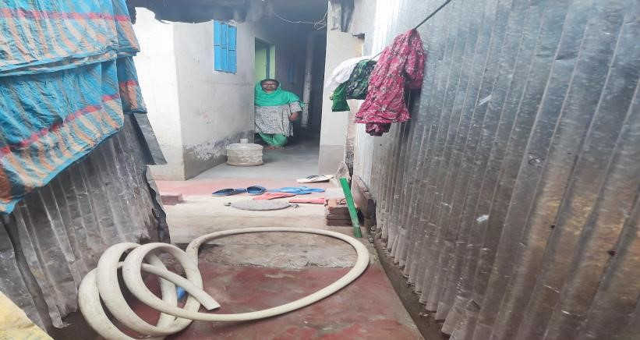
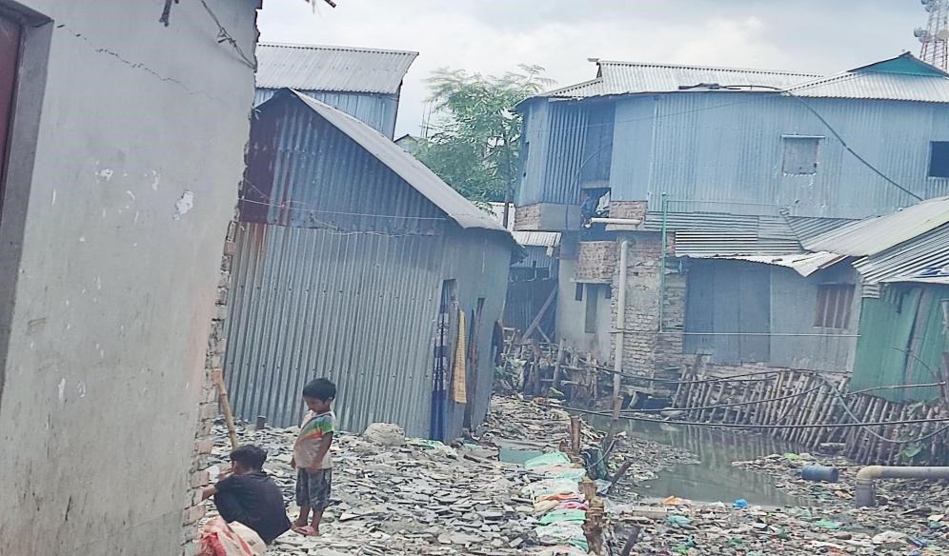

Korail Slum's Clinic (Alo Clinic)
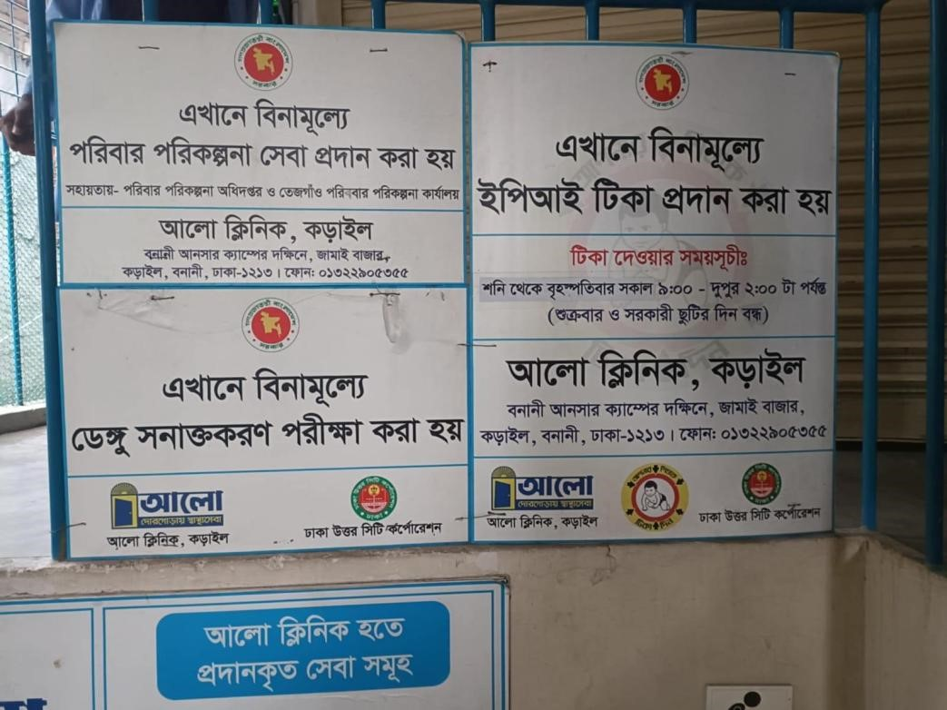

● Korail Slum's Famous tea stall beside beltola-
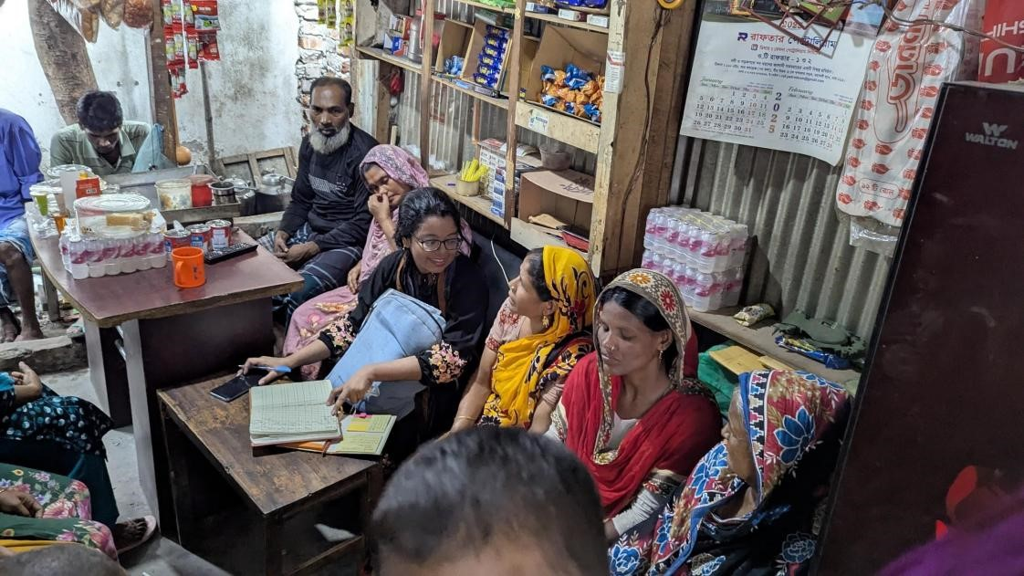

● Kollyanpur Porah Slum's Resource Center
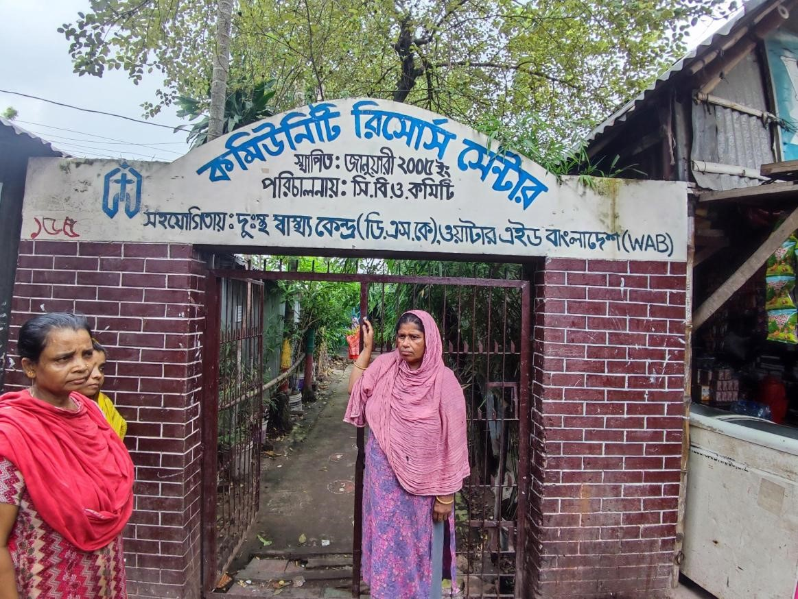

● Kollyanpur Porah Slum's household & Road
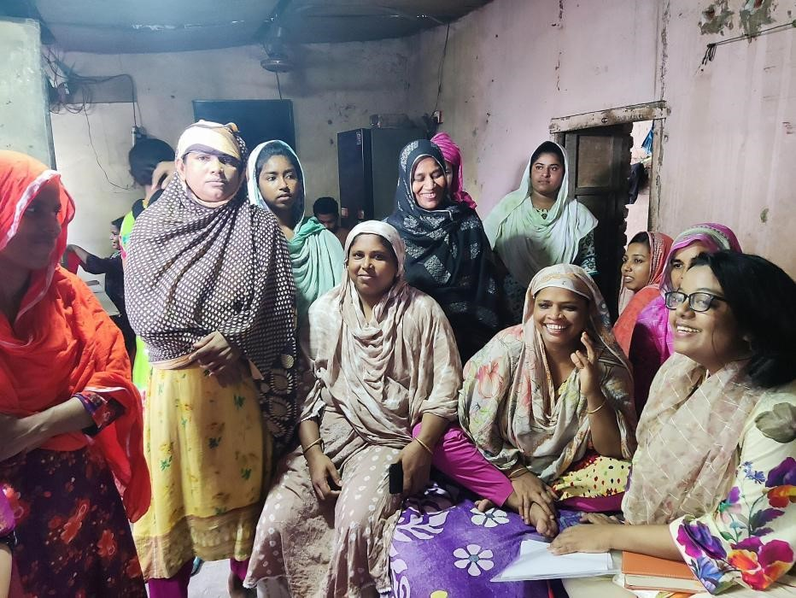

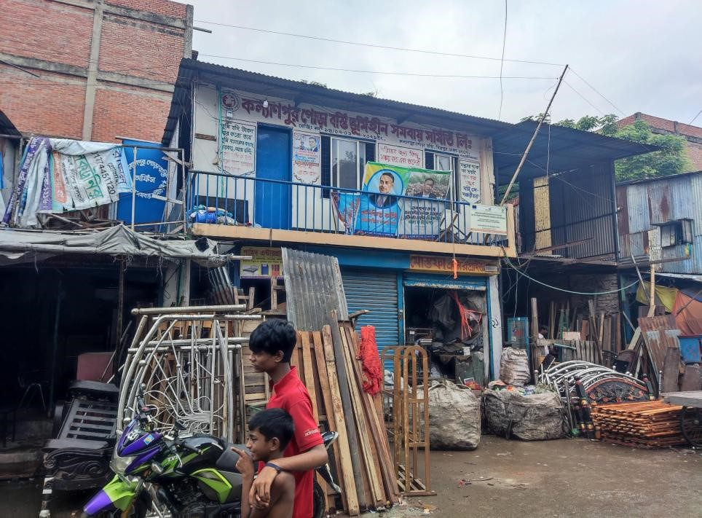

● Kollyanpur Porah Slum's nearby healthcare facility and ActionAid Office

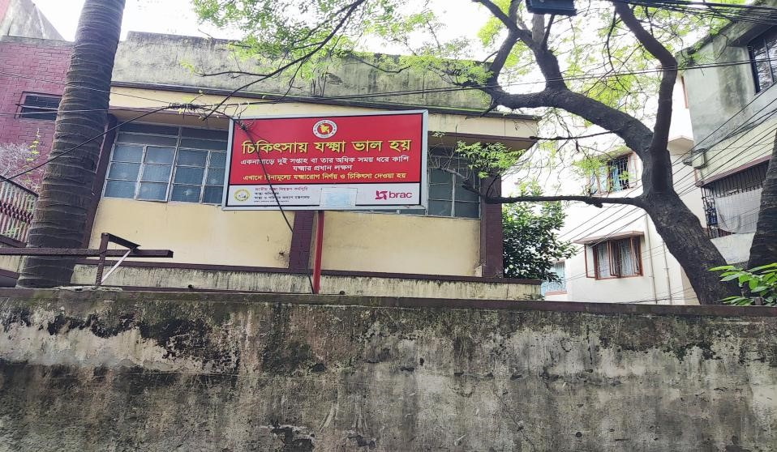
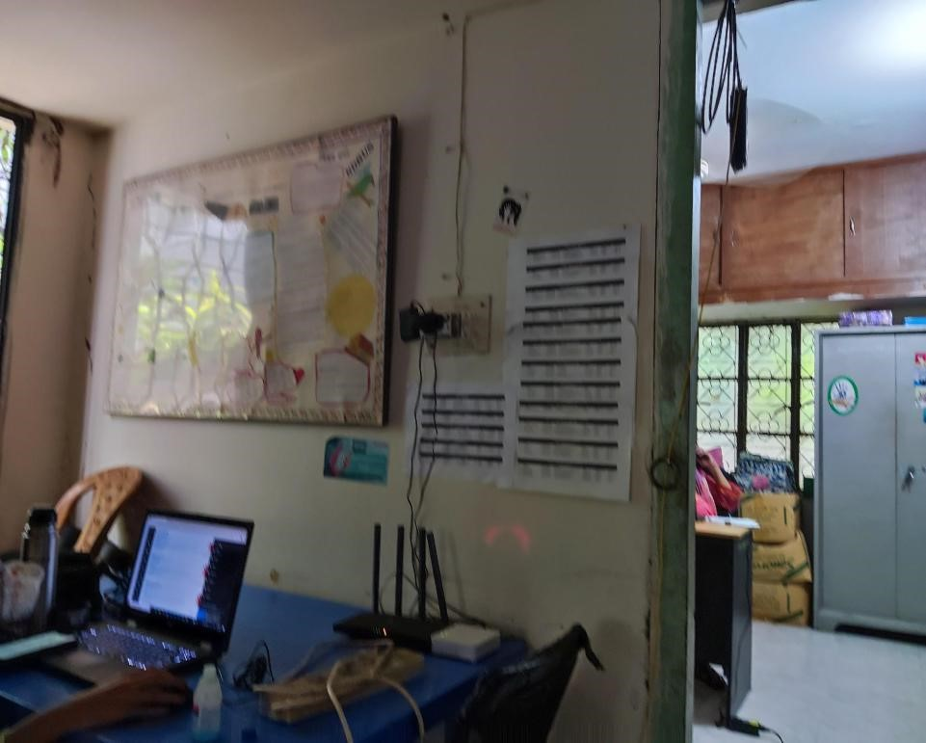

● City Colony Slum's Household & graveyard
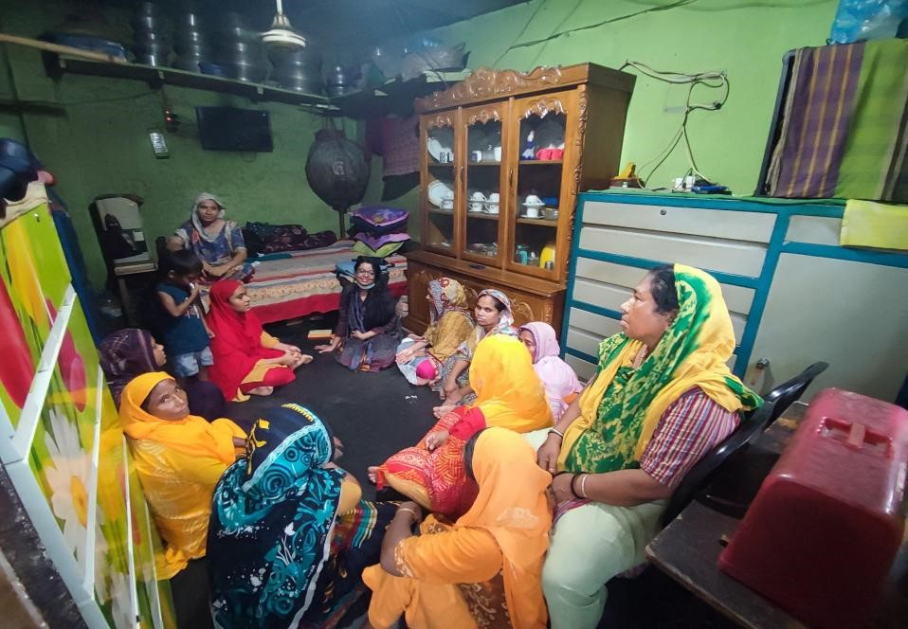

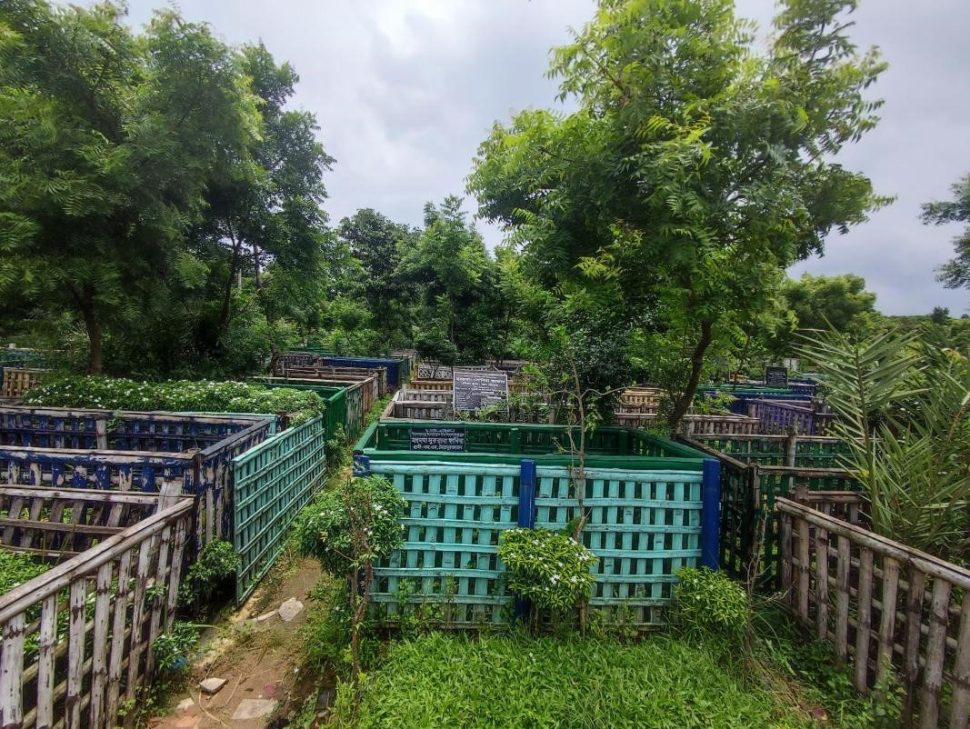

● City Colony Slum's political spot to discuss(Tailor shop and tea stall beside graveyard) 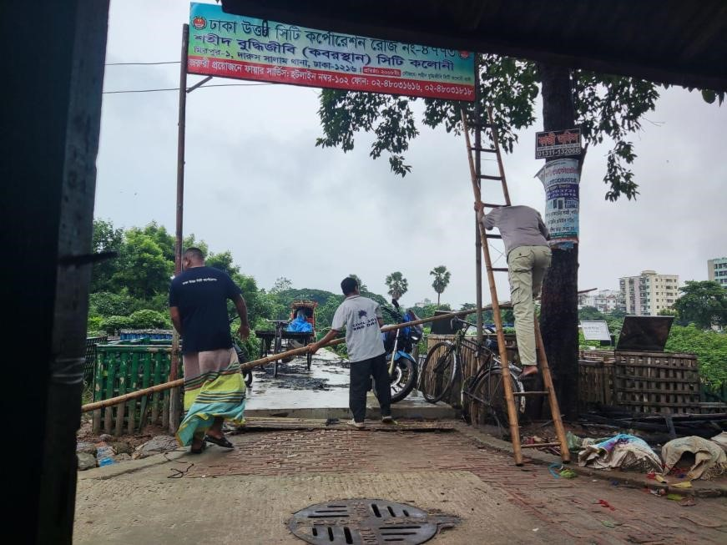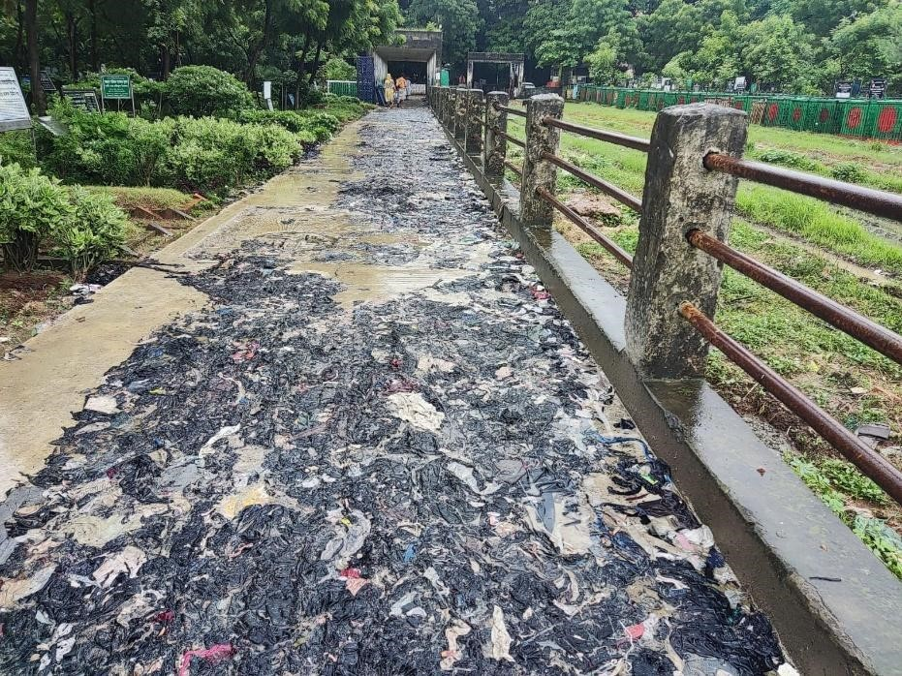

● Permission letter from Authority
